**Forecasting – Coca-Cola**

Visualization shows that it has level, trend, seasonality i.e. Additive Seasonality

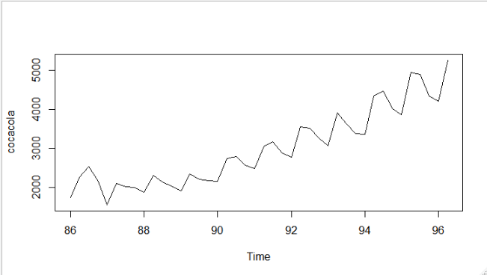

**Using HoltWinters Function 🡺**

**Optimum Values with alpha = 0.2 which is default value assuming time series data has only level parameter**

Alpha = level smoothing, Beta = Trend smoothing, Gama = Seasonality Smoothing

Smoothing parameters:

alpha: 0.2

beta : FALSE

gamma: FALSE

Coefficients:

[,1]

a 3225.544

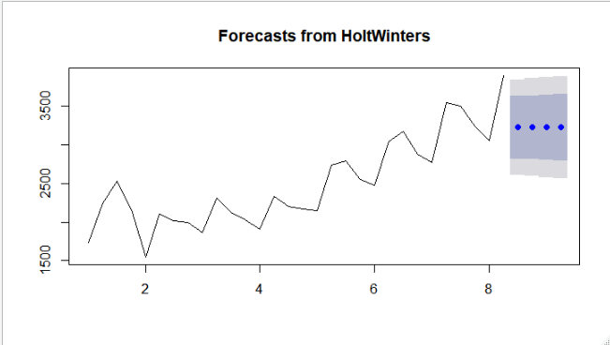

By looking at plot the forecasted values are not showing any characters of train data.

**Optimum values with alpha =0.2, beta=0.1 assuming time series data has level and trend parameter**

Smoothing parameters:

alpha: 0.2

beta : 0.1

gamma: FALSE

Coefficients:

[,1]

a 3511.00835

b 64.53687

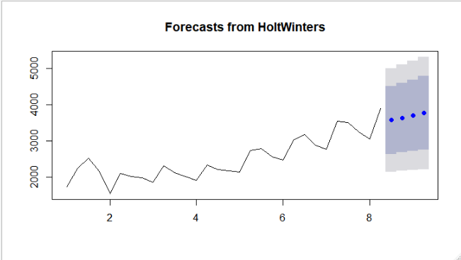

By looking at the plot the forecasted values are still missing some characters exhibited by train data.

**Optimum values with alpha =0.2, beta =0.1, gamma=0.1 assuming time series data has level, trend and seasonality**

Smoothing parameters:

alpha: 0.2

beta : 0.1

gamma: 0.1

Coefficients:

[,1]

a 3309.55652

b 73.30491

s1 395.37160

s2 116.52079

s3 -264.43056

s4 329.28824

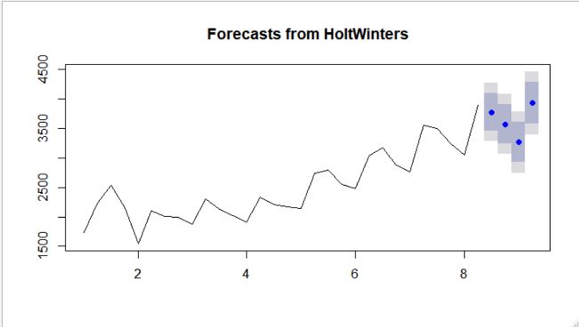

**By looking at the plot the characters of forecasted values are closely following historical data.**

**Without optimum values 🡺**

Smoothing parameters:

alpha: 0.4922576

beta : FALSE

gamma: FALSE

Coefficients:

[,1]

a 3533.182

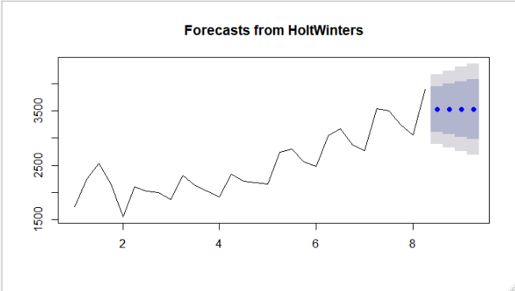

Smoothing parameters:

alpha: 1

beta : 0.1756433

gamma: FALSE

Coefficients:

[,1]

a 3899.000

b 157.449

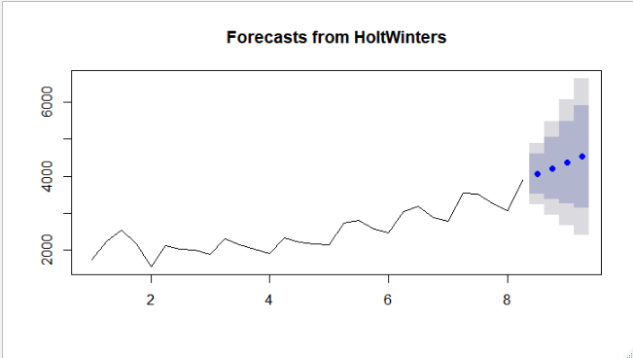

Smoothing parameters:

alpha: 0.3311204

beta : 0.3143241

gamma: 0.8982952

Coefficients:

[,1]

a 3325.14975

b 84.77172

s1 424.00738

s2 68.52519

s3 -164.13388

s4 570.19776

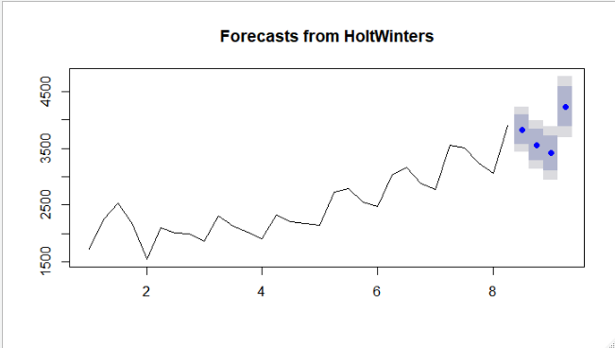

**By looking at the plot the characters of without optimum forecasted values are closely following historical data.**